1. Draw a use case diagram to model for Online Voting System. A web-based voting system that will help to manage elections easily and securely, the voter should be able to successfully cast his vote or it should be a failure. There should be no intermediate state. In case of failures the voter should be allowed to retry immediately. The voting data should be consistent throughout the system. If we are replicating the data, we do not want any scenario where one database shows Voter-1 has voted Candidate-1 and another database has an old entry for Voter-1 showing he has voted for Candidate-2. We should always have strong consistency.

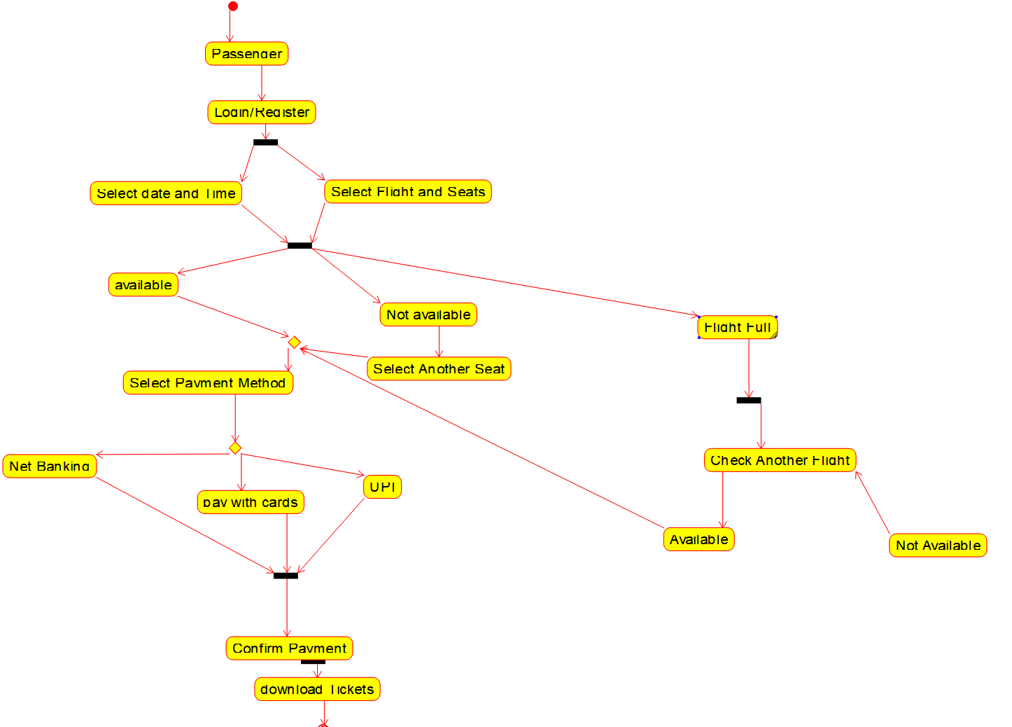

1. Draw a use case diagram for Library Management System is an automation system used to manage a library and the different resource management required in it like cataloguing of books, allowing check out and return of books, invoicing, user management, etc. The user can search for book details using a few book properties (Book ID, Title, Author, and Publisher). Searching should return details about all the book copies that match the search query.

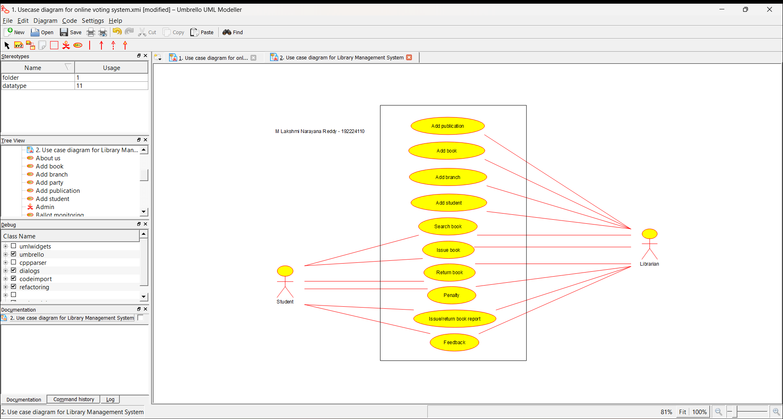

1. Draw and validate Flowchart to compute quotient and remainder between two integers can be calculated by using the division ( / ) and modulus ( % ) operators respectively. To compute the remainder of the division of two floating point numbers, the library function fmod() is used. This function considers quotient as an integer number and the remainder as a floating-point number.

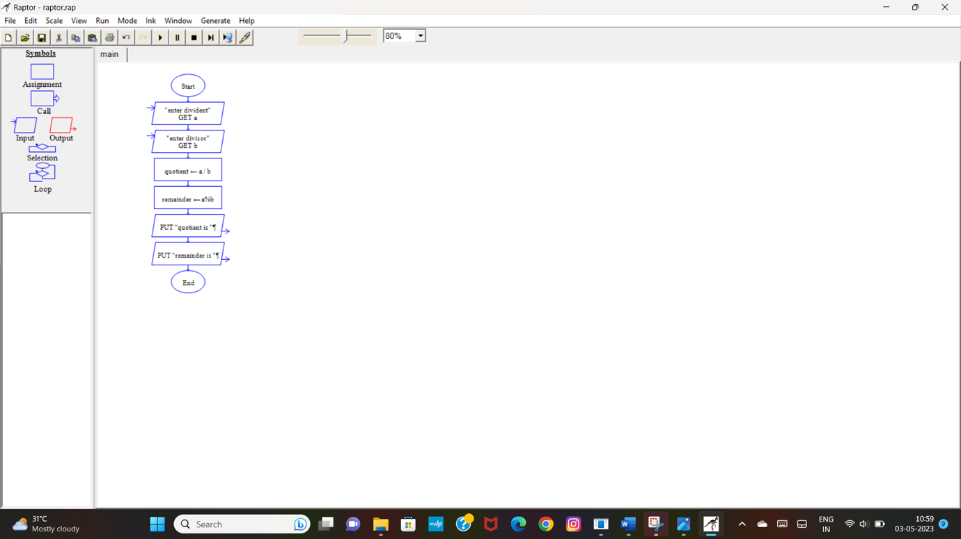

1. Design a shopping cart system. How is the cart updated when the application is open on multiple pages? When an item is added to the cart, store the update in the server. Therefore, a page refresh on any tab will keep everything up to date. If you don't want to rely on a refresh, you could try some sort of polling mechanism. If the web browser on Focus event happens (assuming it's there), poll the server for a quick update if there is one.

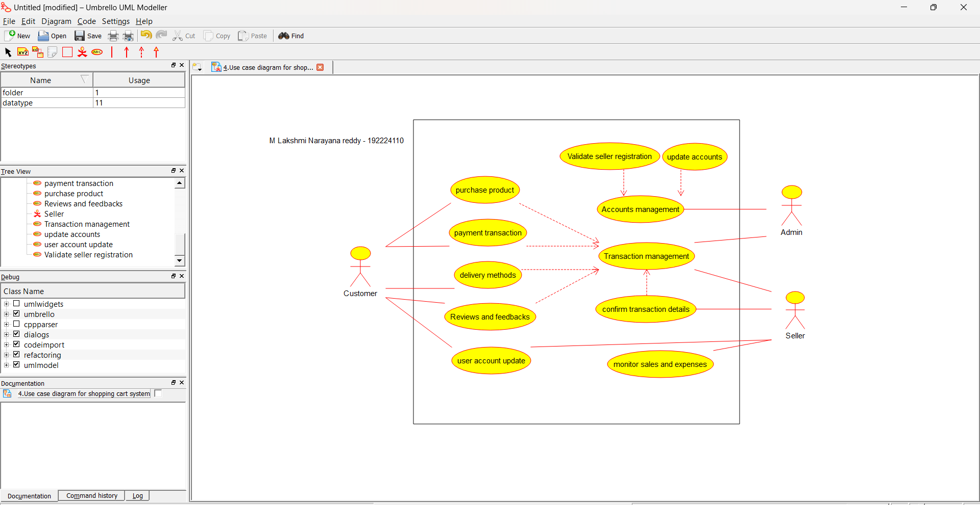

1. Draw the use case diagram is a graphic depiction of the interactions among the elements of the Railway reservation system for maintaining admin user can search ticket, view the description of a selected ticket, add a ticket, update a ticket and delete a ticket and it shows the activity flow of editing, adding and updating of the customer. The user will be able to search and generate reports of payment, Booking and train schedules.

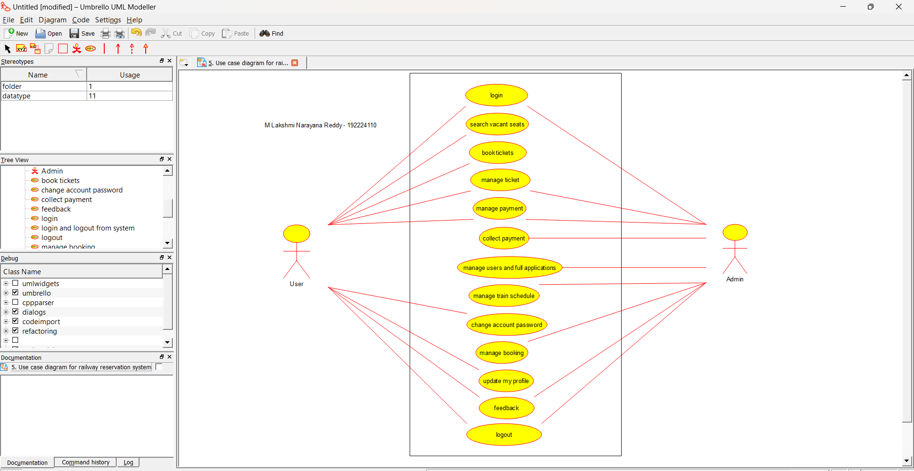

1. Draw a USE-CASE diagram for the Hospital Management System. The activities of the hospital system are listed below. Receive the patient id, Patient name, pharmacy, laboratory, doctor, administrator, record officer, test report, drug management, test management, user management, dispense drug using CASE tools.

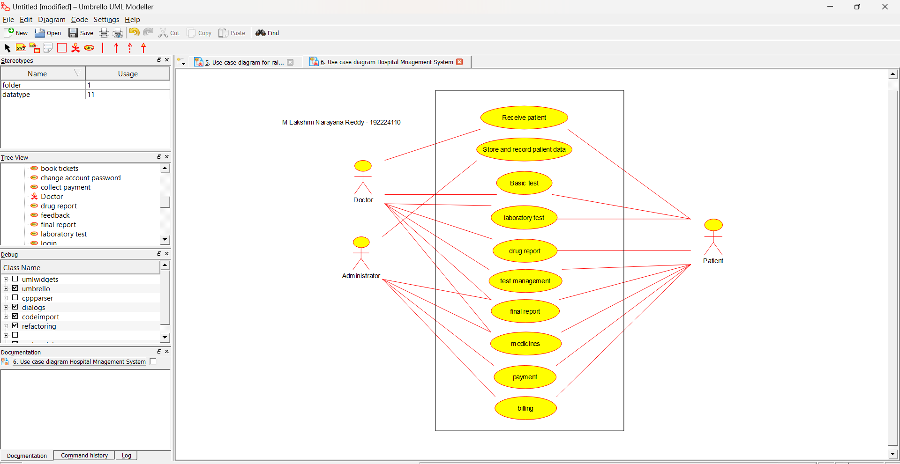

1. Draw a USE-CASE diagram for an ATM System using CASE tool. The banking system allows a customer to access the financial transactions by ATM System; it has a step by step process describing the work of this process and elaborates what work can be done by customer, banking system, administrator and technicians with the ATM system.

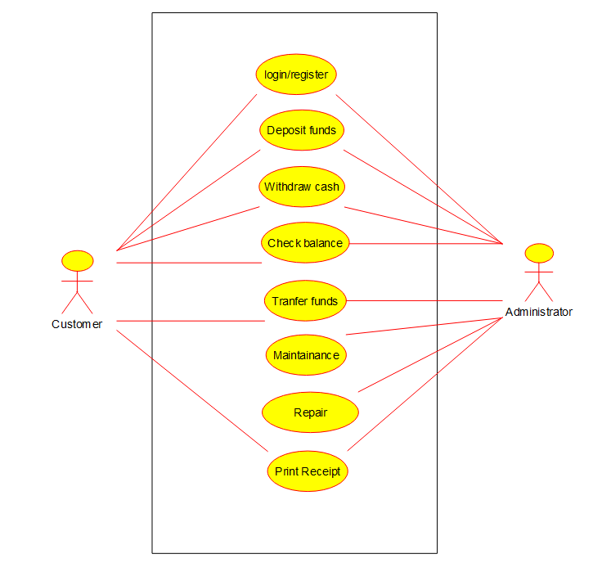

1. Draw a USE-CASE diagram for Online college management System Manage student’s information and status, manage courses and subjects, Manage Instructors and designation, record all transactions Draw a USE-CASE diagram for Online Airline Management System which is a dedicated and highly configurable system for all airlines, which can be easily accessed by all users. It helps the users to book flights without visiting offline booking counters. This system can be accessible by any user from any location at any time. In such a system, a passenger should be able to view the availability of flights’ details, as per their requirement. They can book the flights online and can also cancel the reservation. The administrator manages the passenger booking system and updates the reservation status using CASE tools.

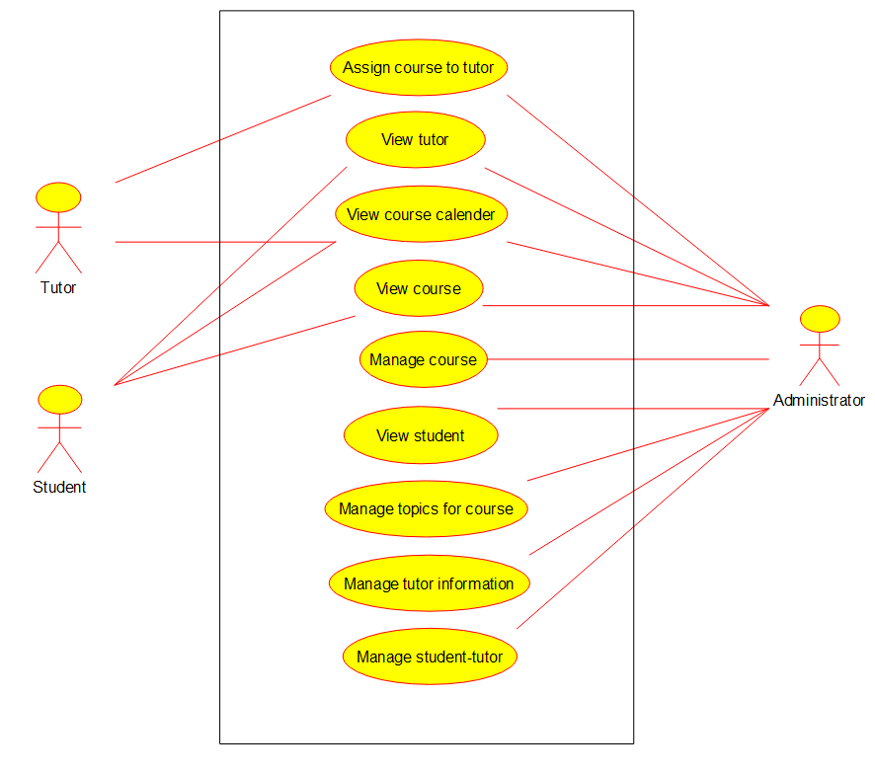

1. Make an Online Airline Reservation System. The activities of the Online Airline Reservation system are listed below user, admin, LOGIN, MANAGE CLASSES, MANAGE WAITING LIST, MANAGE HOLDS, MANAGE DEADLINES, LOGOUT, using this has a step-by-step process draw a USE-CASE diagram.

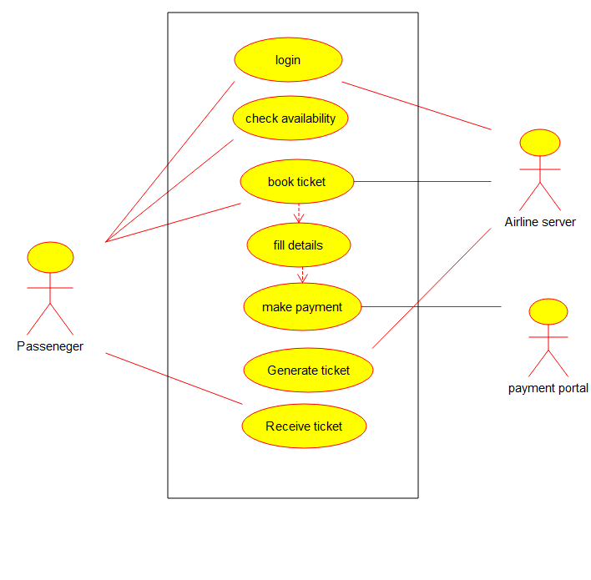

1. CLASS diagram Draw a Class diagram for Library Management System using CASE tools.

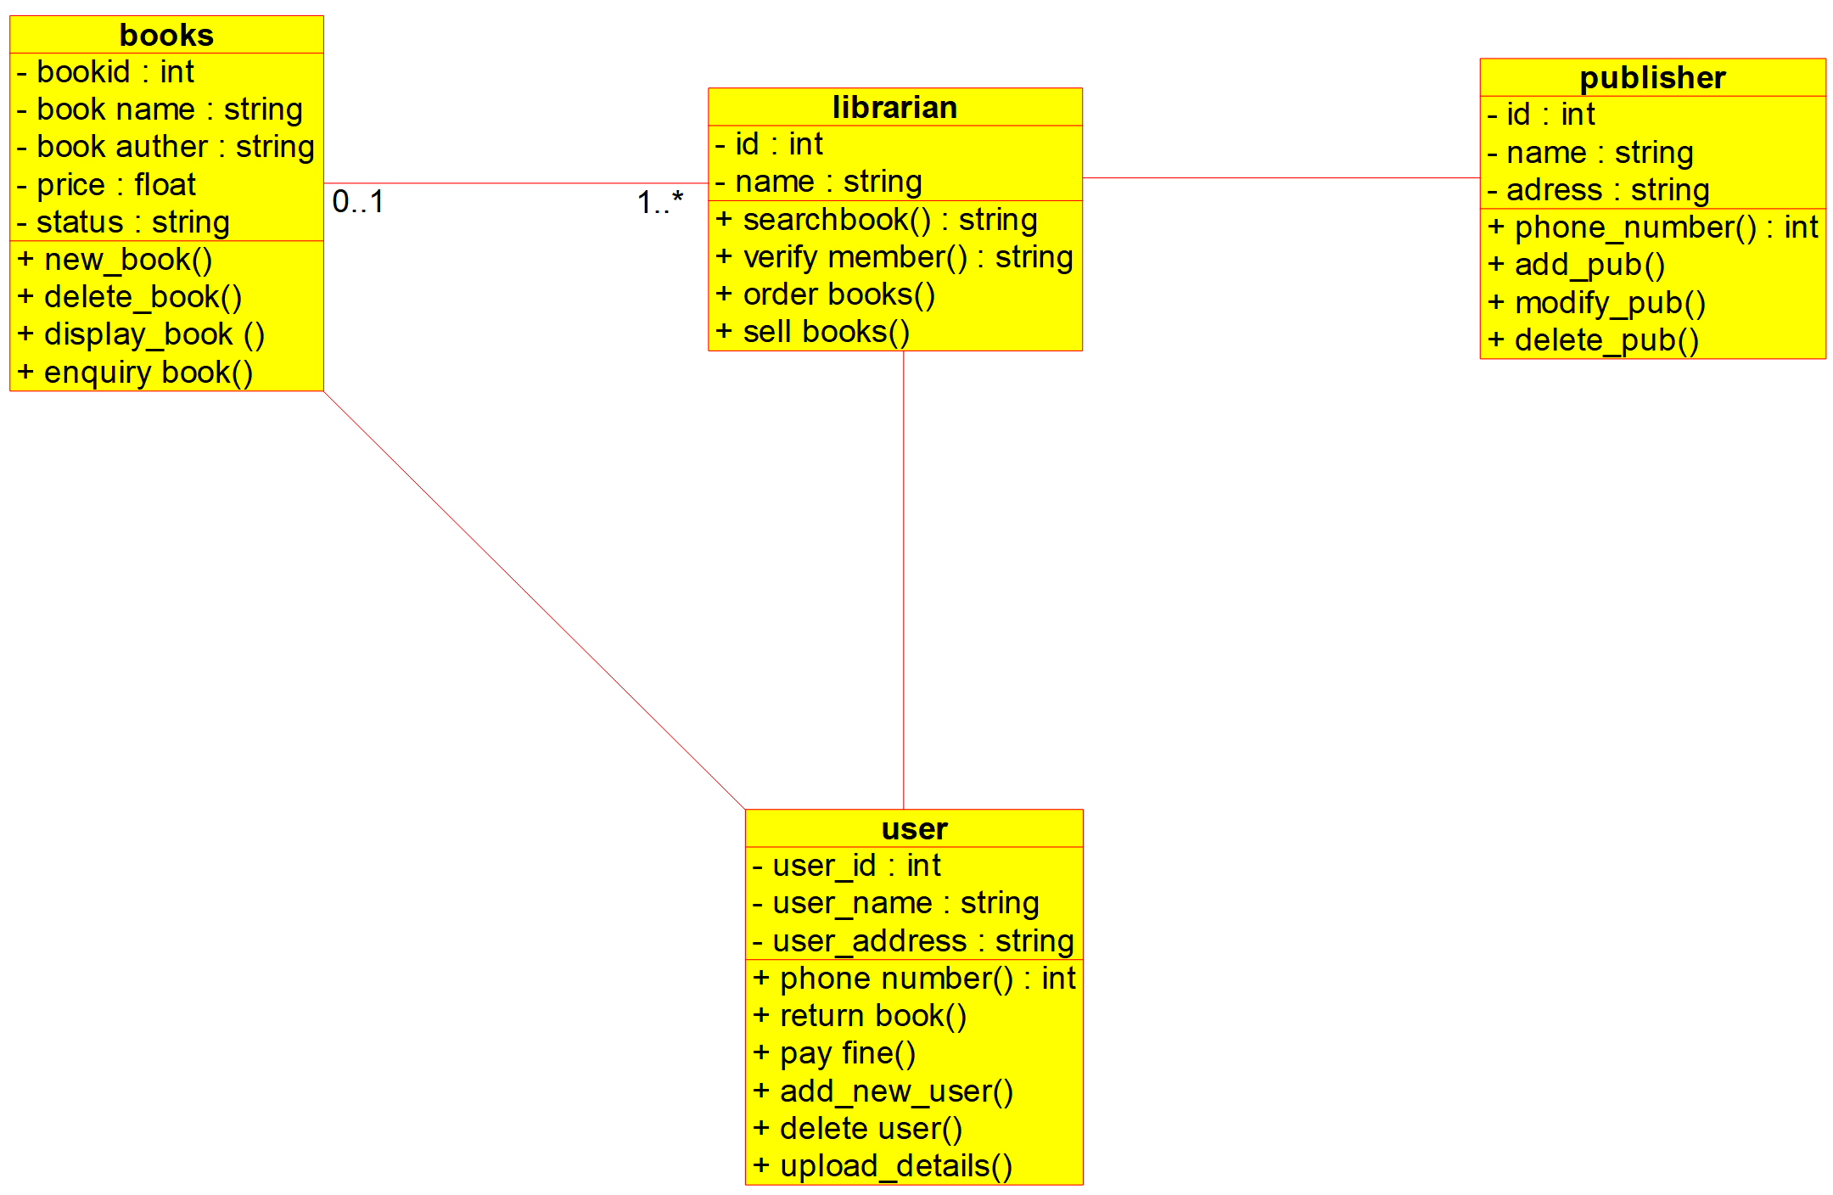

1. Draw a Class diagram for Online Voting System using CASE tools. eVote is an election system that facilitates voters to record their secure and secret ballot electronically. It has a friendly user interface and enables voters to cast their votes in a few simple steps. We ensure the authenticity of the voters and the votes cast by them along with non-traceability of the casted vote elaborate the whole process of e-voting.

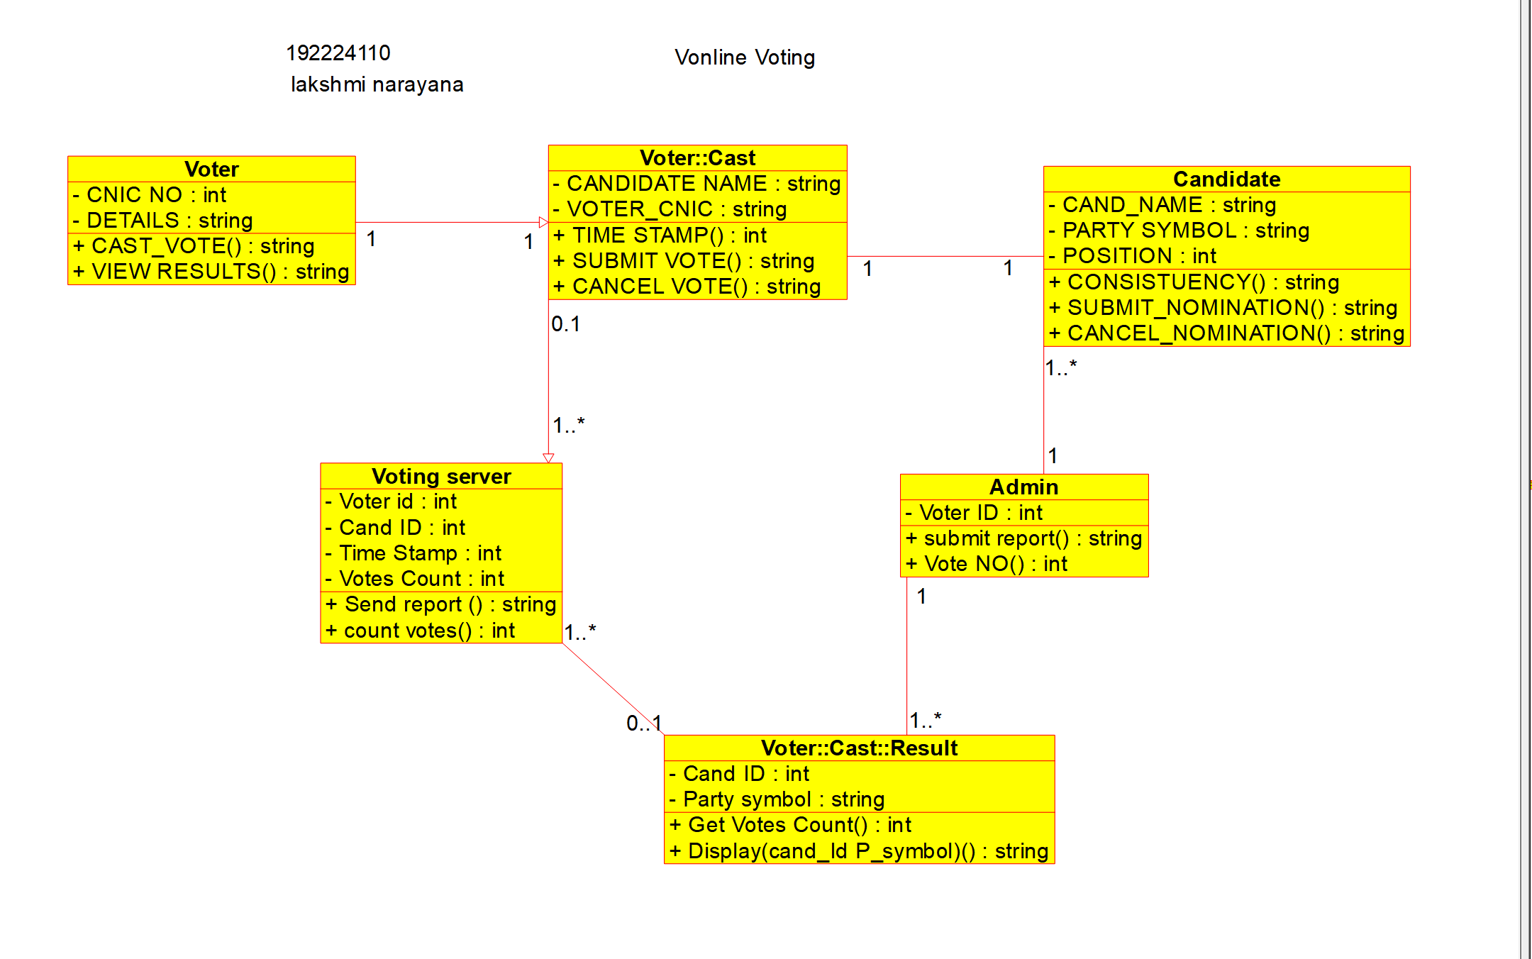

1. Draw a Class diagram for Library Management System using CASE tools. Designing use case diagram for the library management system. User who registers himself as a new user initially is regarded as staff or student for the library system. Librarians have a key role in this system. Librarian adds the records in the library database about each student or user every time issuing the book or returning the book, or paying a fine. Design the class diagram for this
2. Draw a Activity diagram for Online Voting System for a software platform that allows groups to securely conduct votes and elections using CASE tools. The voters should be able to register via some proper authority. Construct a system in which the voters should see the list of candidates present in his constituency. A voter should be able to cast his vote to a candidate and that voter should cast only 1 vote at a time Draw an Activity diagram for Library Management System using CASE tools.

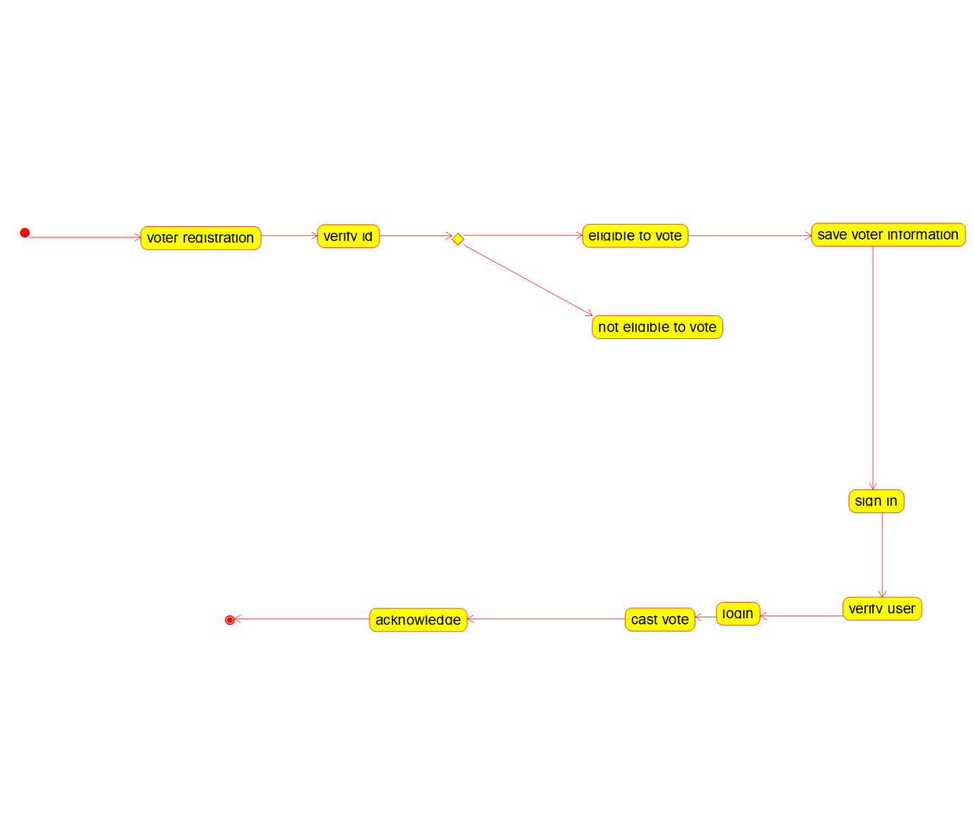

1. Draw a Activity diagram for Library Management System using CASE tools constructing User who registers himself as a new user initially who is regarded as staff or student. After getting the library card, a new book is requested by the user. After, requesting, the desired book issue the book to the user. Renew the book if the user needs the book again. Add the agent as Librarian and the user in the activity diag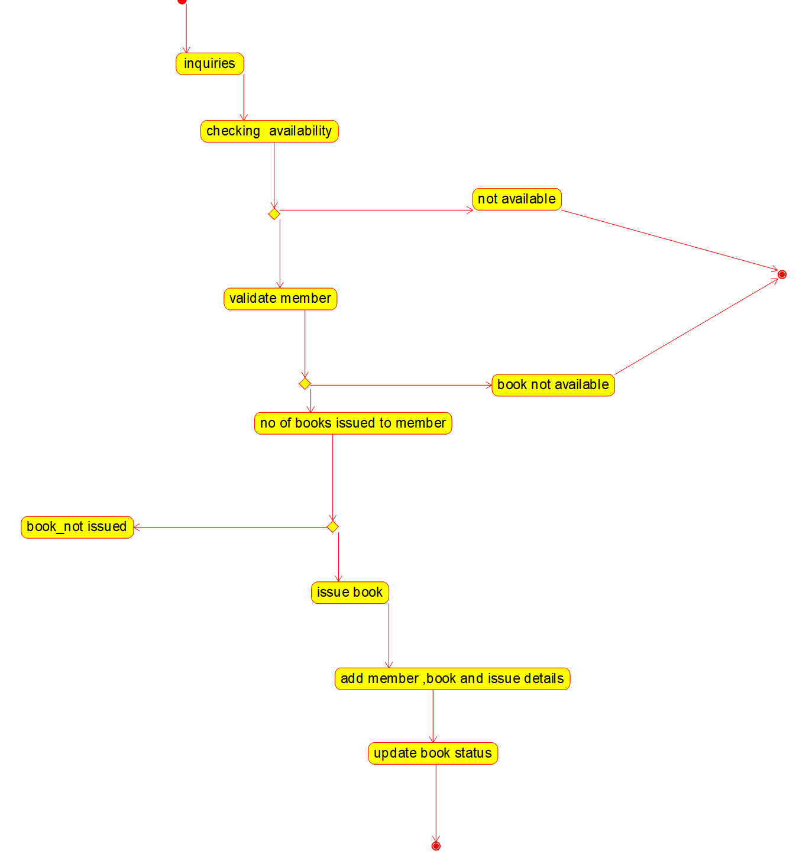ram
2. Draw an Activity diagram for the Online Shopping system using CASE tools with standard steps like Login, Search, Browse, add to cart, edit cart, delete cart, confirm purchase, make payments, and receive items, rate website login and logout on the system.

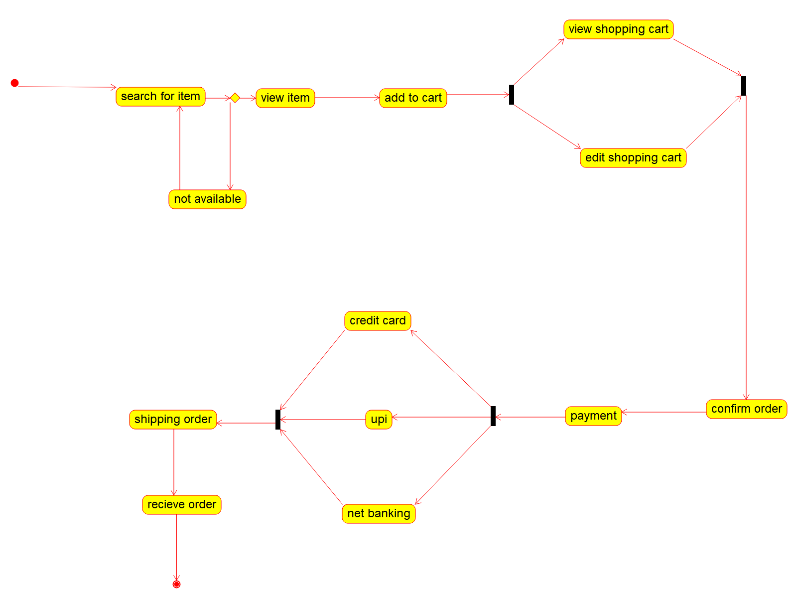

1. Draw an Activity diagram for Online Railway Reservation System using CASE tools that the two actors would be a customer and a ticket counter having search train, check availability of train, if “yes” then go to booking of train if “no” Quit the system model. Print details like make payment, print ticket, cancel ticket; refund ticket feed details like name of the passenger, date and time of journey, amount of the journey.

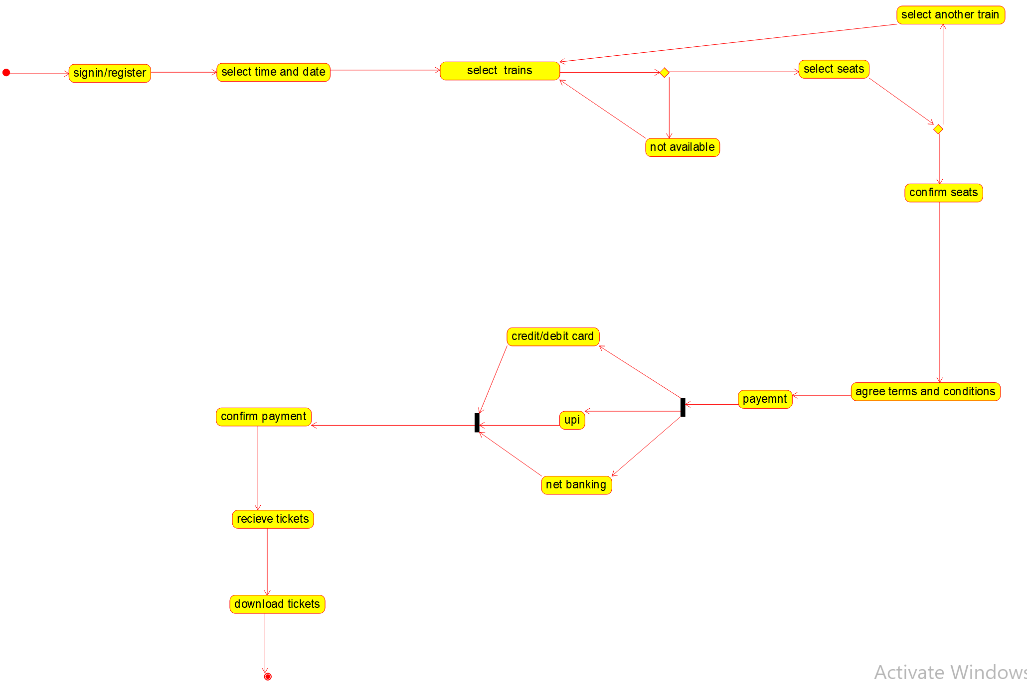

1. Draw an Activity diagram for Hospital Management System using CASE tools with Familiarizing activity Diagram Components, parts that are used to make the diagrams which determine the targeted users. Analyse the activities included plot of Hospital, Patient, Doctor, Receptionist the relationship. Show how the user, the hospital staff, can interact with the system model.

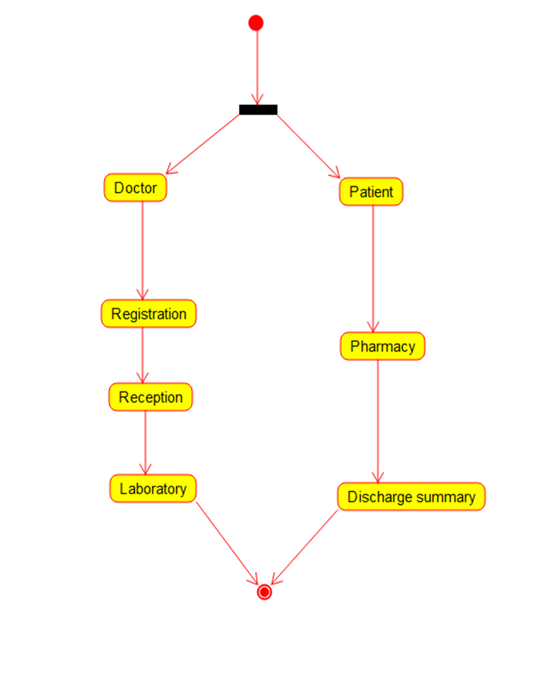

1. Using Raptor- Draw the flowchart to check whether the given number is a palindrome or not. This scenario is a word, number, phrase, or other sequence of symbols that reads the same backwards as forwards. AdaptA method for this problem is to reverse digits of number, compare the reverse of number. If both are same, then return true, else false using Raptor tool.

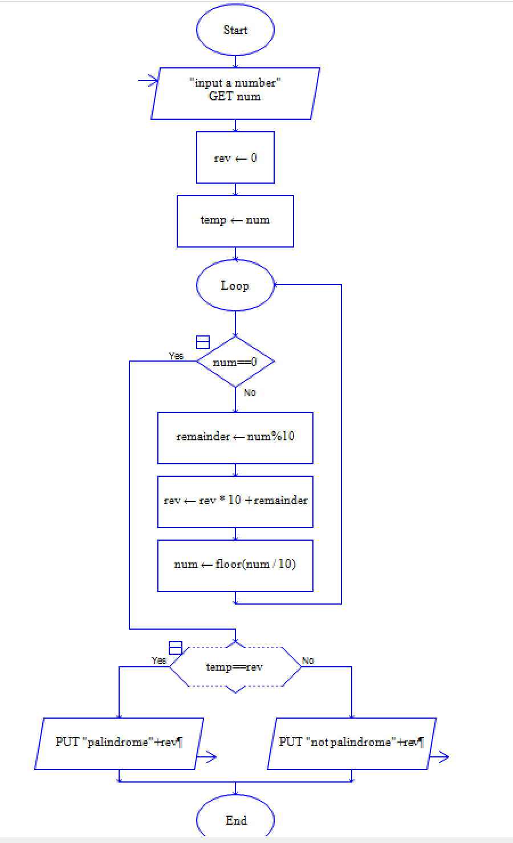

1. Using Raptor – Draw and validate a flowchart for a given string of lower-case English alphabets. One can choose any two characters in the string and replace all the occurrences of the first character with the second character and replace all the occurrences of the second character with the first character. Using Raptor draws and validates the flowchart lexicographically smallest string that can be obtained by doing this operation at most once.

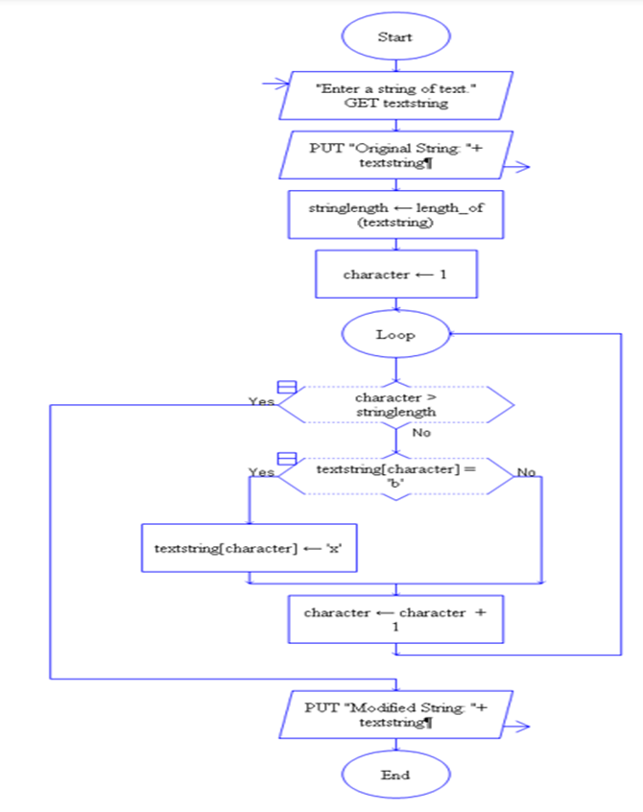

1. The string is a sequence of characters placed in double quotes (” “). Performing different operations on string data is called String Handling. Strings are immutable. Whenever a change to a String is made, an entirely new String is created. If we want to store a group of characters we can use a char array. String provides various methods to perform different operations on strings Using Raptor draw a flowchart to display the total number of characters in the string and return it.

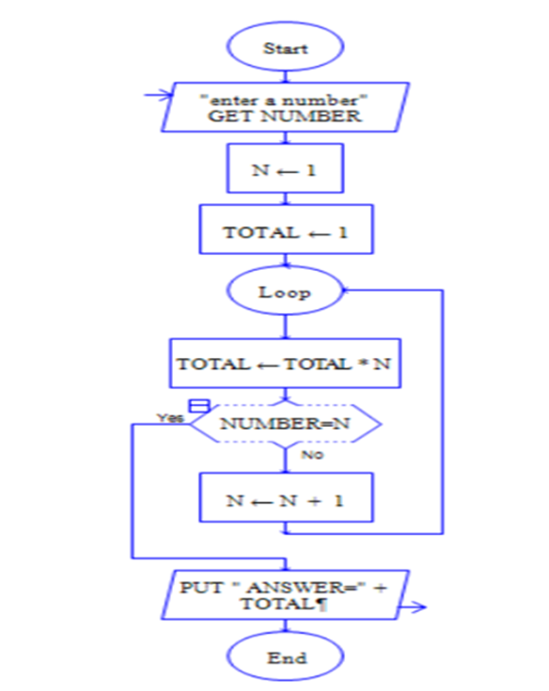

1. Take for example the RSA encryption system: All arithmetic is done modulo n, with n=pq and p, q large primes. Decryption in this system relies on computing Euler's phi function, φ(n), which is hard to compute (hence the system is hard to break) **unless** you know the prime factorization of n (which is also hard to compute unless you know it upfront). Hence you need a method to generate primes (the Miller-Rabin primality checking algorithm is usually used here) and then you construct n by multiplying the primes you have found. Using Raptor, draw the flowchart to find whether p and q are prime or not.

.

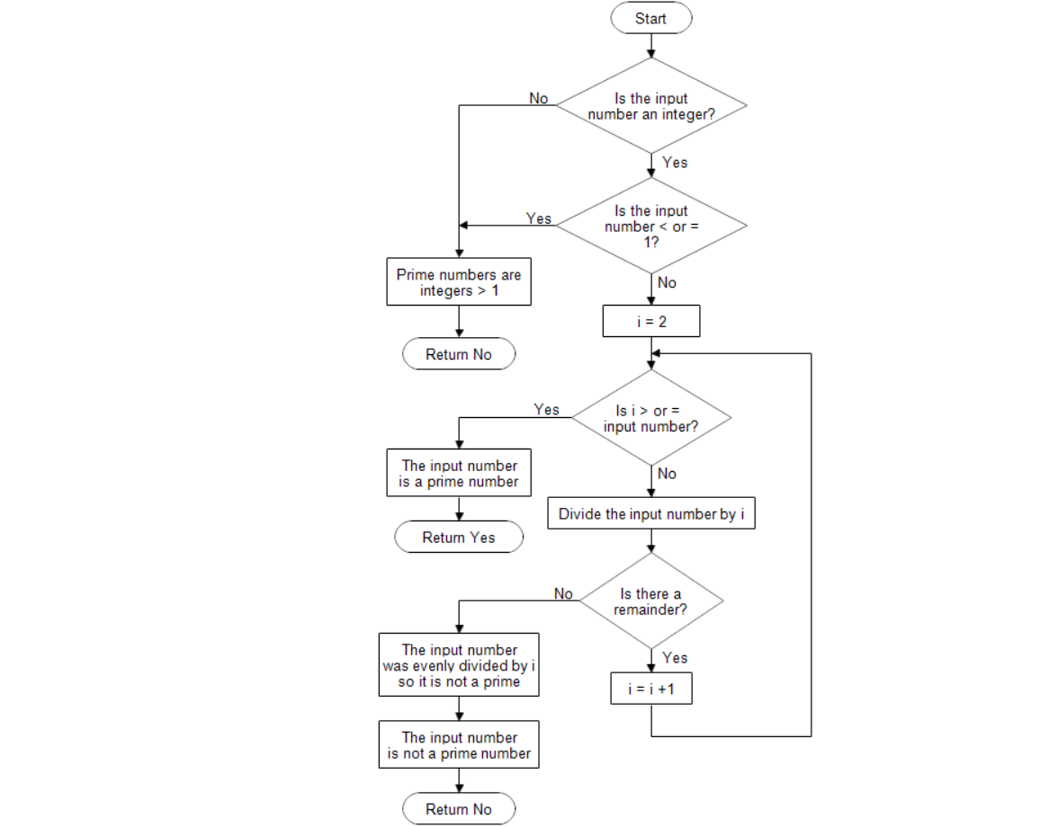

1. Cyclomatic Complexity in Software Testing is a testing metric used for measuring the complexity of a software program. It is a quantitative measure of independent paths in the source code of a software program. Cyclomatic complexity can be calculated by using control flow graphs or with respect to functions, modules, methods or classes within a software program. Cyclomatic complexity for a flow graph G is V(G)=E-N+2.Cyclomatic complexity is a software metric (measurement), used to indicate the complexity of a program, Cyclomatic complexity = E - N + P where, E = number of edges in the flow graph, N = number of nodes in the flow graph, P = number of nodes that have exit points. Find Cyclomatic Complexity for a graph having number of edges as 17, number of nodes as 13 and number of predicate nodes in the fl

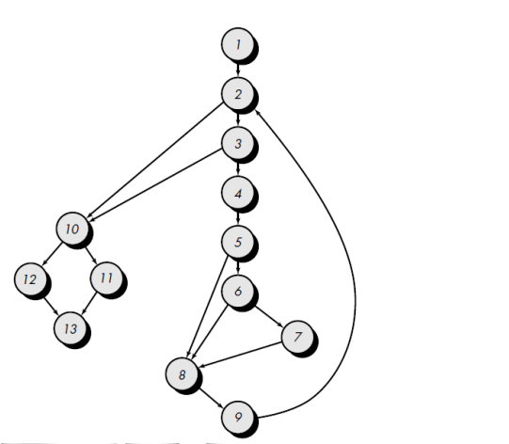

V(G) = 6 regions

V(G) = 17 edges – 13 nodes + 2 = 6

V(G) = 5 Predicate nodes + 1 = 6

1. Design an activity diagram for an automated online banking system which shows the flow of type of account, withdrawal, deposit, balance enquiry and check whether the person has a loan. If there is a due in loan then push the notification “pay the due amount.

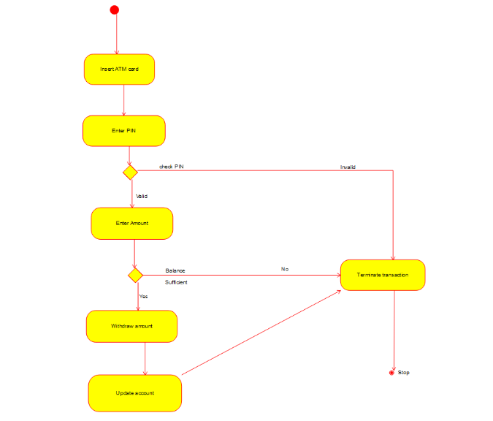

1. Develop an activity diagram for an e-library online public access catalogue. The activities of the system are listed below. Patrons of a library can search the library catalogue online to locate various resources - books, periodicals, audio and visual materials, or other items under the control of the library. Patrons may reserve or renew items, provide feedback, and manage their account.



1. Draw a Class diagram for an e-library online public access catalogue. The activities of the system are listed below. Patrons of a library can search the library catalogue online to locate various resources - books, periodicals, audio and visual materials, or other items under the control of the library. Patrons may reserve or renew items, provide feedback, and manage their account.



1. Draw a Use Case diagram for a Restaurant Systems. The activities of the Restaurant system are listed below. Receive the Customer food orders, Produce the customer ordered foods, Serve the customer with their ordered foods, collect payment from Customers, Store customer payment details, Order Raw Materials for food products, Pay for Raw Materials and Pay for Labour.

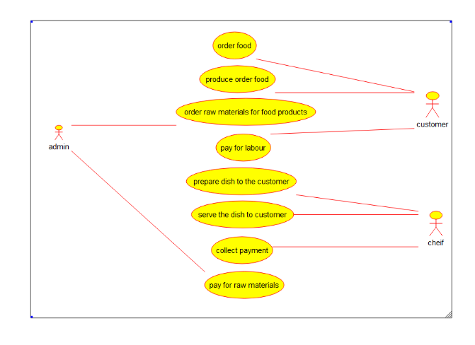

1. Draw a Class diagram for a Restaurant Systems. The activities of the Restaurant system are listed below. Receive the Customer food orders, Produce the customer ordered foods, Serve the customer with their ordered foods, collect payment from Customers, Store customer payment details, Order Raw Materials for food products, Pay for Raw Materials and Pay for Labour.

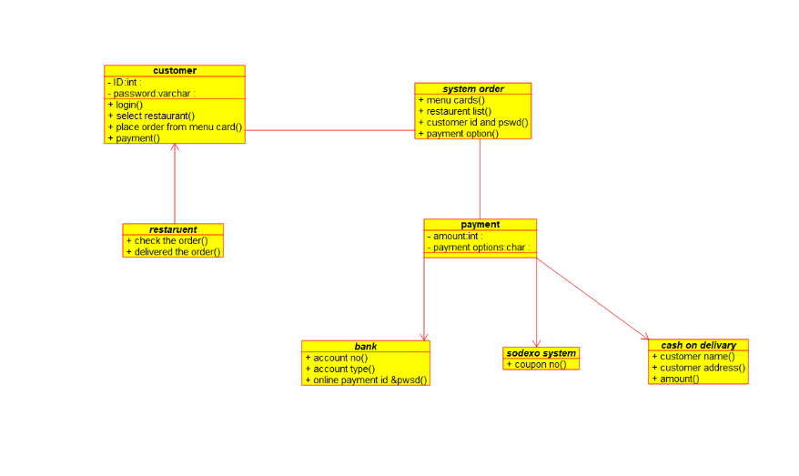

1. Make a class diagram to model for a quiz system. A user can request a quiz for the system. The system picks a set of questions from its database, and composes them together to make a quiz. It rates the user’s answers and gives hints if the user requests it. In addition to users, we also have helpers who provide questions and hints. And also administrators who must certify questions to make sure they are not too trivial and those they are correct.

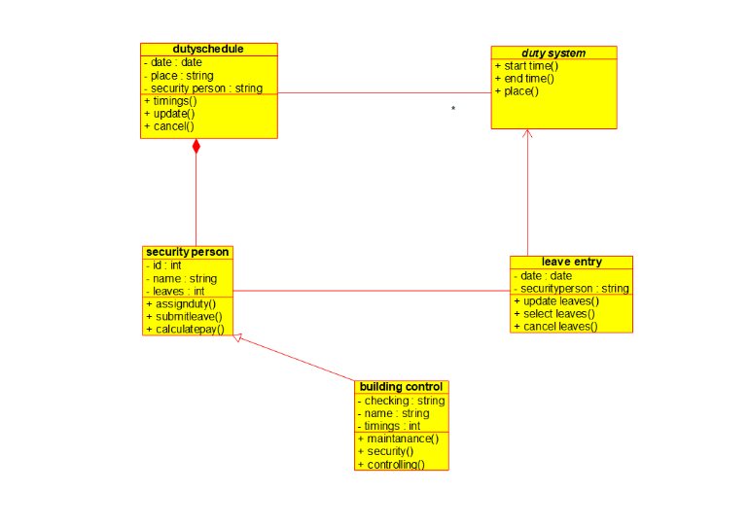

1. Draw a Use case diagram to model for a quiz system. A user can request a quiz for the system. The system picks a set of questions from its database, and composes them together to make a quiz. It rates the user’s answers and gives hints if the user requests it. In addition to users, we also have helpers who provide questions and hints. And also, administrators who must certify questions to make sure they are not too trivial, and that they are correct

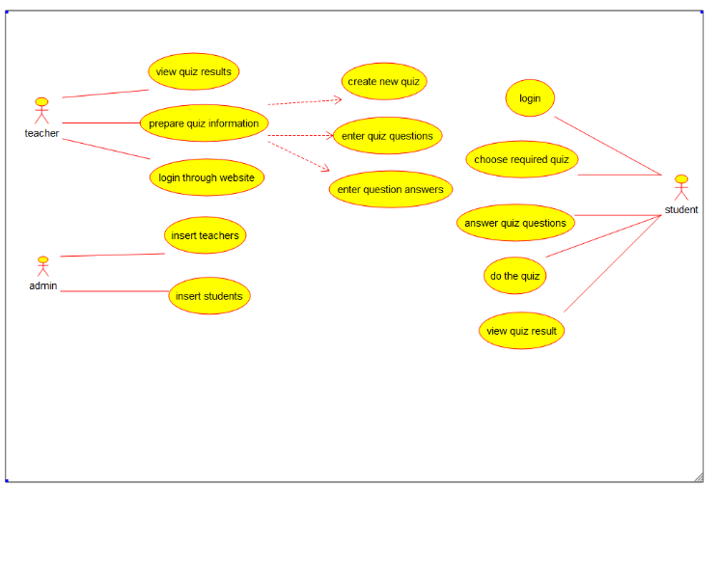

1. Using Raptor- Draw and validate the flowchart to calculate Factorial of a number. Factorial of a positive integer (number) is the sum of multiplication of all the integers smaller than that positive integer. For example, factorial of 5 is 5 * 4 * 3 * 2 * 1 which equals 120.

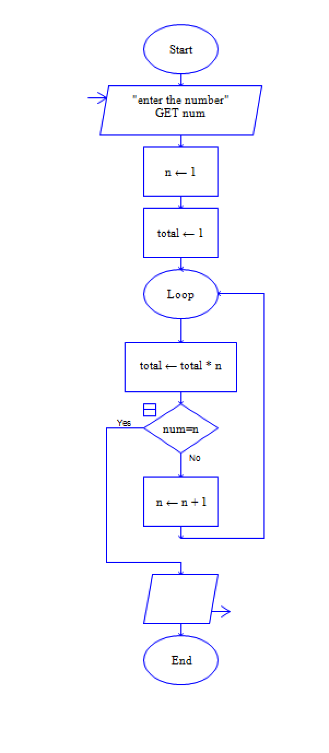

1. Using Raptor – Draw and validate the flowchart to find odd series of the given number. The odd numbers are the numbers which are not divisible by 2. They are 1,3,5,7,9,11,13,15,17,19 etc.. Using Raptor – Draw and validate the flowchart to find even series of the given number

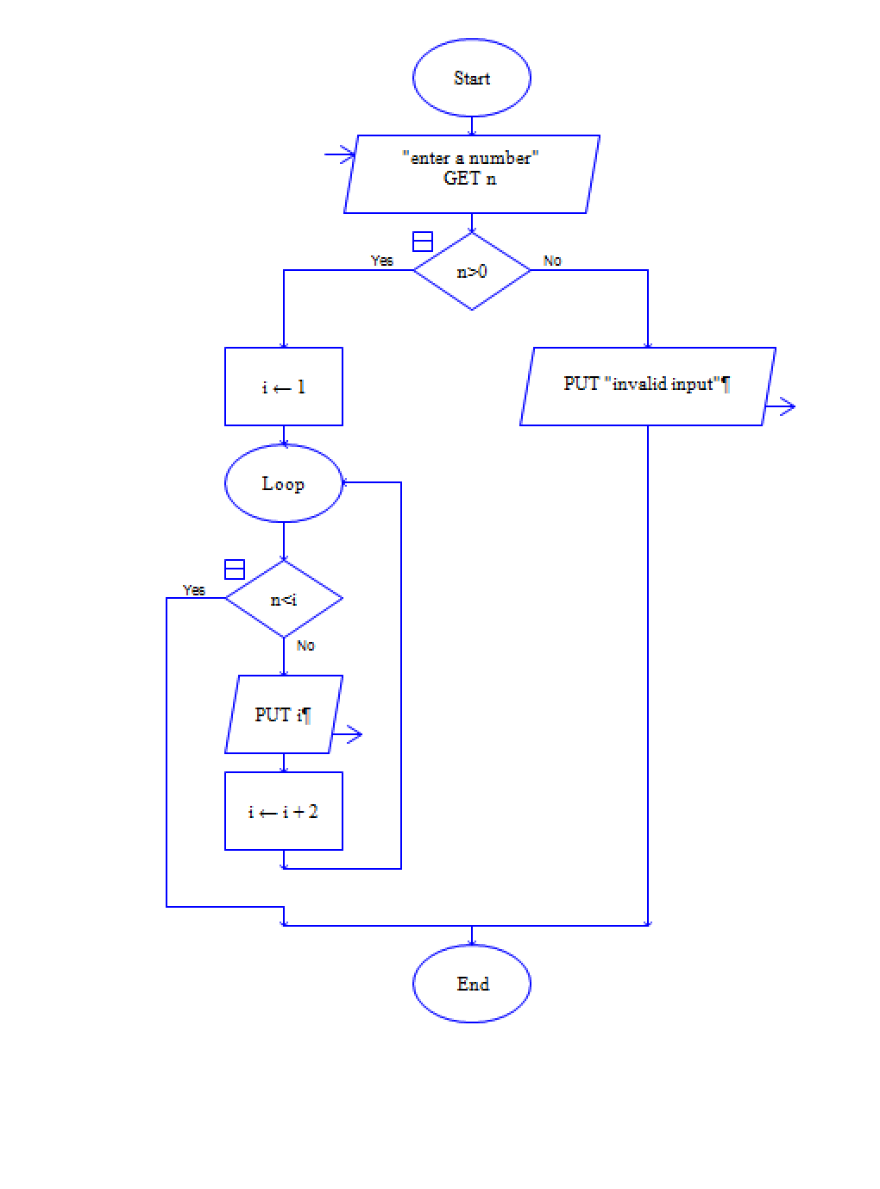

1. Draw the flowchart that uses Raptor, how to reverse a given String. If the string is "hello" then, the output should be "olleh". We can use this concept to check the palindrome. Because the palindrome string will have the same value even after we reverse it.

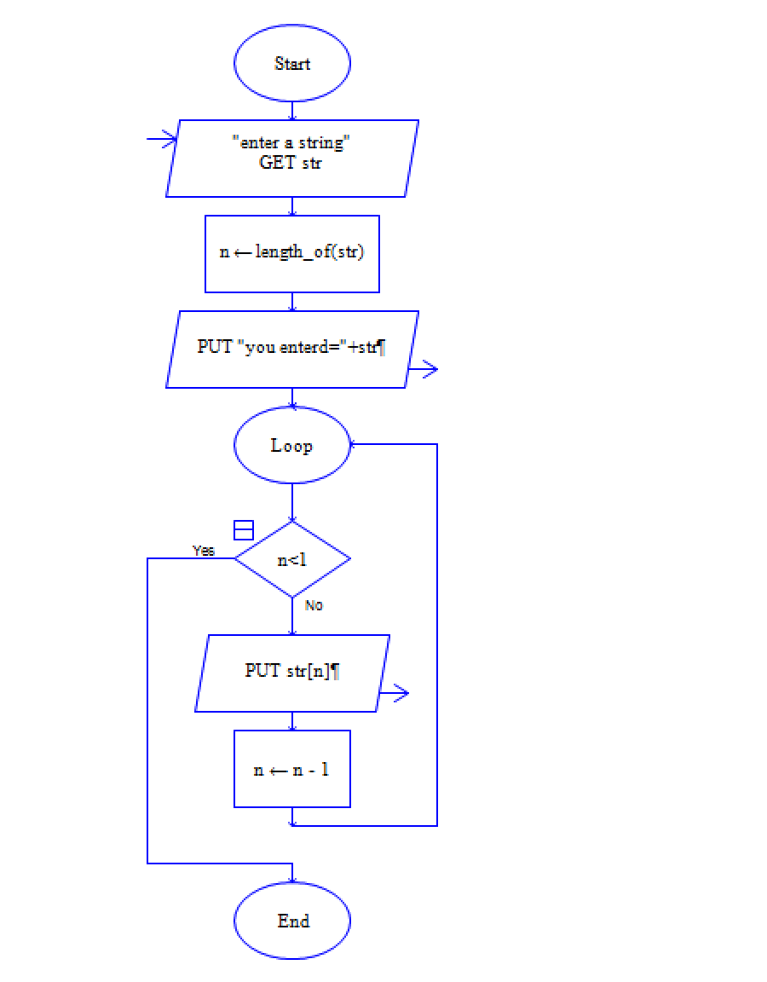

1. Draw the flowchart using Raptor, The formula of the sum of first n natural numbers is S=n(n+1)2S=n(n+1)2 . If the sum of first n natural number is 325 then find n. Using Raptor – Draw the flowchart to find largest of n numbers

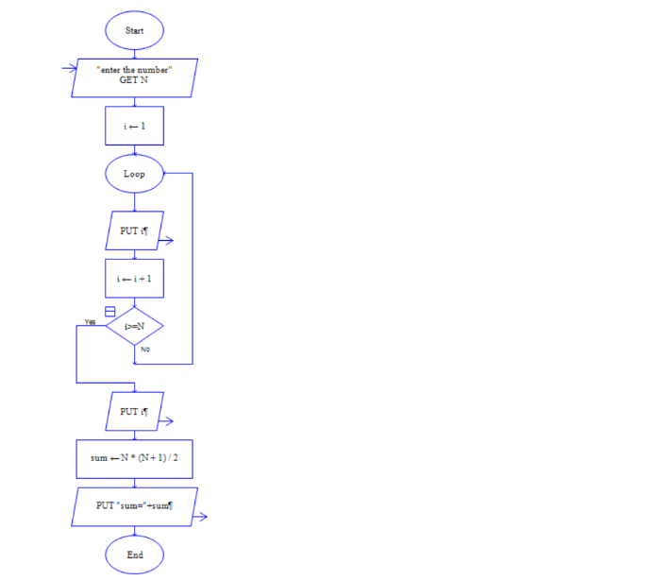

1. Draw the flowchart using Raptor; Write a shell script to find the largest of n numbers in a range. Accept the size of a range (N) and accept each number in the range. Use an editor to write your script Change its permission to run as a script. Run your script with these sets of input below. The output should be preceded by the text "The largest number in this range is '' First range 5, the numbers are 4, 56, 78, 34, 123 Second range 6, the numbers are 99, 33, 1, 15, 25, 33 Find Cyclomatic Complexity for a graph having number of edges as 20, number of nodes as 15 and number of predicate nodes in the flow graph as 4

echo "Enter Size(N)"

read N

i=1

max=0

echo "Enter Numbers"

**while** [ $i -le $N ]

**do**

read num

**if** [ $i -eq 1 ]

**then**

max=$num

**else**

**if** [ $num -gt $max ]

**then**

max=$num

**fi**

**fi**

i=**$((**i + **1))**

**done**

echo $max

cyclomatic complexity calculation:

V(G) = 20 - 15 + (2 × 4)

V(G) = 20 - 15 + 8 V(G) = 13

Therefore, the Cyclomatic Complexity of the graph is 13.

1. Using Raptor- Draw and validate the flowchart to calculate Fibonacci Series which plays a big part in Western harmony and musical scales. Here are the facts: An octave on the piano consists of 13 notes. Eight are white keys and five are black keys. A scale is composed of eight notes, of which the third and fifth notes create the foundation of a basic chord. In a scale, the dominant note is the fifth note, which is also the eighth note of all 13 notes that make up the octave. Eight divided by 13 equals 0.61538 the approximate Golden Ratio. Using Raptor, draw and validate the flowchart.

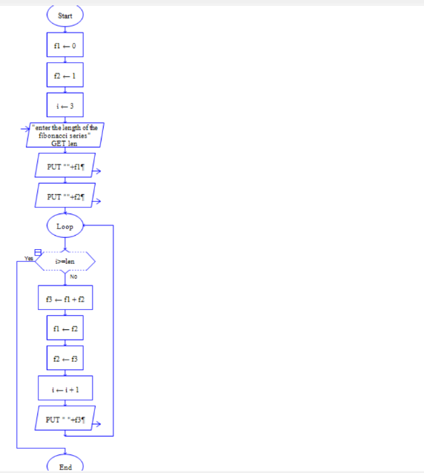

1. Draw the flowchart using Raptor; given a number n find the smallest number evenly divisible by each number 1 to n.

Examples:

Input: n = 4

Output: 12

Explanation: 12 is the smallest numbers divisible by all numbers from 1 to 4

Input: n = 10

Output: 2520

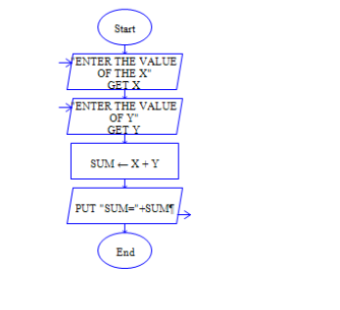

1. E-wallet is an online prepaid account where one can stock money, to be used when required. As it is a pre-loaded facility, consumers can buy a range of products from airline tickets to grocery without swiping a debit or credit card. You are required to design a similar EWallet Management System (EMS) using Use case diagram



1. A college has more than thousand security persons, who are instructed to give duties at different places within the campus. Additionally, they also maintain a routine, which contains all information, such as Date, Duty Start Time, Duty End Time, and Place. Most importantly, all the places are covered by at least one security person. If a security person takes leave, manual entry is done against that person. Finally, at the end of a month, the security persons get paid for their duties, while considering the number of leaves as well. You can see that the manual calculation/operation is a heavy task for the security manager. Therefore, the objective is to build an Online security management system using class diagram through which entire security system within the campus can be controlled in an efficient manner

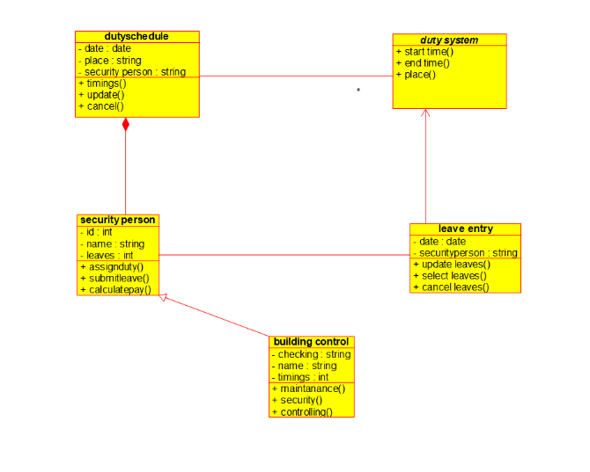

1. The Internet has led to discussion of e-democracy and online voting. Many people think that the internet could replace representative democracy, enabling everyone to vote on everything and anything by online voting .Online voting could reduce cost and make voting more convenient. This type of voting can be done for e-democracy, or it may be used for finalizing a solution, if many alternatives are present. Online voting make’s use of authentication, hence it needs security, and the system must be able to address obtaining, marking, delivering and counting ballots via computer. Advantage of online voting is it could increase voter turnout because of convenience, and it helps to reduce fraud voting.

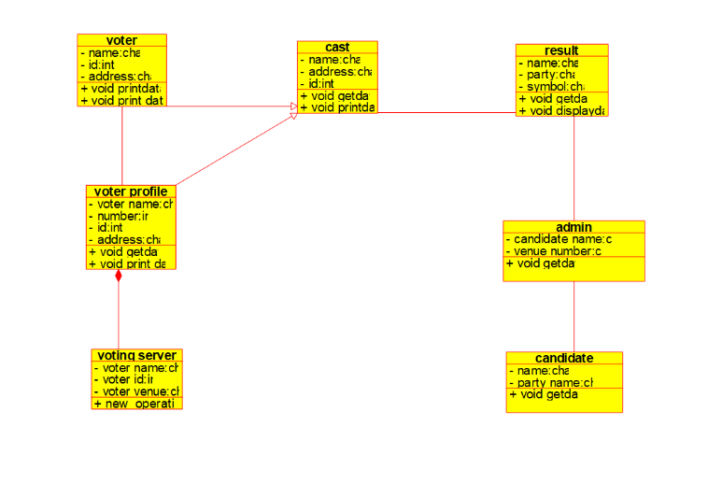

1. Construct a flowchart using raptor and Check whether a string is palindrome or not a palindrome is a word, number, phrase, or other sequence of symbols that reads the same backwards as 